Alveo Design Tutorials
Alveo에 있는 FPGA를 활용하여 특정 기능 블록을 구현하고, host program(C++ API 사용)에서 사용할 수 있는 kernel을 만들어, XRT(Xilinx Runtime)을 통해 실제로 Alveo를 사용하는 것까지의 과정을 직접 해보면서 전체 flow에 대해 학습하기 위함

- 기능 블록의 RTL 구현
- RTL design을 Vivado IP로 packaging하고 이후 Vitis kernel 구현 + Runtime 테스트
하기 전에, Tutorial의 개요를 먼저 정리한다.
https://github.com/Xilinx/Vitis-Tutorials/tree/2021.1/Hardware_Acceleration/Design_Tutorials/05-bottom_up_rtl_kernel
Bottom-up RTL Kernel Flow with Vitis for Acceleration
- Xilinx® Vitis™ unified software platform provides a mature and proven RTL kernel (core of computer’s operating system) design methodology
- Can focus on core accelerating module
Tutorial
- Introducing bottom-up Vitis-based RTL kernel construction & wrap-up process, host-kernel interaction with XRT
- Using command-line interface (Use using virtual terminal or terminal to interact with computer, user directly use keyboard to input command)
- Using examples to illustrate relevant concept and steps
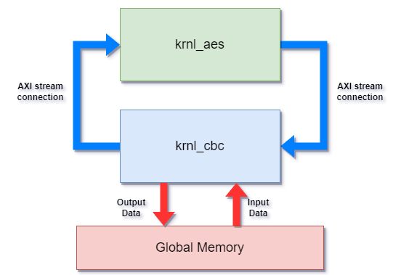
- Simple AES accelerator design with two kernels, krnl_aes, krnl_cbc
- Krnl_aes: Core AES computation core with AXI streams slave & master ports.
- Krnl_cbc: Handle host-kernel data exchange, implementation of AES-ECB and AES-CBD modes with krnl_aes module
Alveo™ Data Center accelerator cards are the target platform for this tutorial
- Packing RTL design to Vitis-compliant RTL kernel with command line interface
- Using MMCM (Mixed-Mode Clock Manager- generate multiple clocks with defined phase and frequency relationships to a given input clock)/PLL (Phase Locked Loop-system that controls an output signal using a phase difference between an input signal and a signal fed back from the output signal) in the RTL kernel
- Using Vivado XSIM to simulate the design
- Using Xilinx AXI VIP to verify the RTL design with AXI interface
- Using three RTL kernel control modes with XRT: ap_ctrl_none, ap_ctrl_hs, ap_ctrl_chain
- Host programming for the RTL kernel with XRT Native API
- Using Vitis HW emulation to get an insight look of the RTL kernel operation
Tutorial Contents
- AES Introduction and Core AES Computing RTL Module
Introduction to AES algorithm and core RTL module for AES acceleration. RTL AES module uses native Verilog interface.
- Creating and Packing Vitis Compatible RTL Kernel krnl_aes
Introduce Vitis kernel called krnl_aes, can be integrated into Vitis. The krnl_aes has four internal AES pipelines & includes AXI control salve and AXI stream master/slave ports.
Has mix control model of ap_ctrl_none and ap_ctrl_hs. MMCM IP used in this kernel to generate required core clock, while AXI interface uses standard platform clock.
Also integrate krnl_aes kernel with a few HLS kernels to generate usable XCLBIN (bit stream) file. Host test program with XRT native API is used to test the function of the krnl_aes kernel.

RTL Module: Aes

About the AES Encryption Algorithm
- Symmetric-key encryption algorithm, the same key is used for both encrypting and decrypting the data
- Input & Output data blocks for the AES algorithm: 16Bytes (128bits)
- AES has 3 key length types: 128-bit, 192-bit, 256-bit
- Encryption operation called key-expansion must be run when a key is given
- Including lots of bit-wise & byte-wise operation, suitable to be implemented with the hardware accelerator
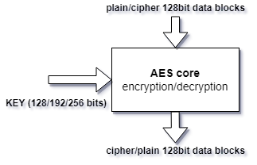
- Five usage models
  - Electronic codebook (ECB)*
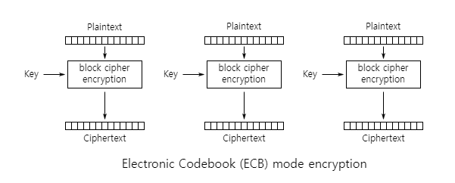
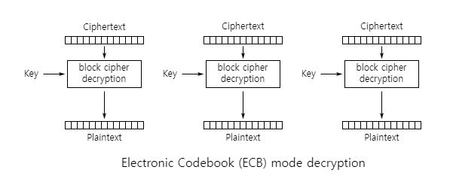
  - Cipher block chaining (CBC)*
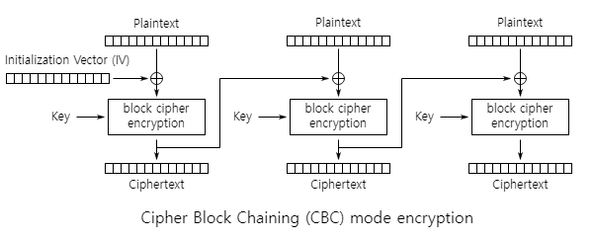
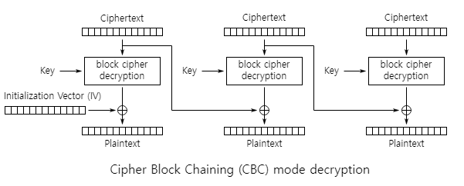
  - Cipher feedback (CFB)
  - Output feedback (OFB)
  - Counter (CTR)
RTL Module AES
The core moduel of AES encryption/decryption module, using native RTL ports interface.
Name | Width (bits) | Direction | Description
KEY | 256 | in | AES key for encryption or decryption, when using 128/192 bit key, aligned to MSB (complement 0s to LSB)
NK | 2 | in | AES Key length: 2'b00=128bit, 2'b01=192bit, 2'b10=256bit
NR | 4 | in | Reserved, tie to 4'b0000 for common AES operation
START_CIPHER | 1 | in | When given one cycle active high trigger, cipher operation is executed (encryption or decryption).
START_KEYEXP | 1 | in | When given one cycle active high trigger, AES key expansion operation is executed.
OP_FINISH | 1 | out | When the encryption or decryption job is in progress, OP_FINISH will keep low. OP_FINISH will keep high in idle state.
EXP_FINISH | 1 | output | When the key expansion job is in progress, EXP_FINISH will keep low. EXP_FINISH will keep high in idle state.

RTL Kernel: krnl_aes
Including 4 AES modules, each of which are connected outside with AXI stream slave & master ports, also AXI slave port for kernel control.
Using same settings (encrypt, decrypt mode, key length and key value)
- Using 2 clocks inside: external AXI ports & internal AXI ports and AES cores
AES cores run at a higher freq than platform AXI interconnection
- 2 methods to get the higher clock
To use secondary platform clock provided, ap_clk_2 ports (for Alveo U200, ap_clk (300MHz), ap_clk_2 (500MHz)). ap_clk_2 generated by standalone MMCM in the static region.
To manually instantiate an MMCM inside the RTL kernel, provide additional flexibility – Used by example, krnl_aes including customized MMCM module to generate 400 MHz clock
- Target platform is divided into static region and dynamic region
Customer-instantiated MMCMs in dynamic region are probably driven by an MMCM in static region, might be used to drive the platform bus clock – Causing big clock skew and makes it difficult for synchronous design to meet timing
To ease timing closure, modules driven by customer MMCM should operate in asynchronous mode to the platform bus clock
In example, AXI slave control & 5 AES engines all run in 400MHz, while kernel connected to 300MHz, 9 AXI/AXIS clock converter Ips are used in the top level of the kernel; 1 AXI clock converter for AXI control slave, 4 AXIS clock converters for AXIS slave ports, 4 AXIS clock converters for AXIS master ports.
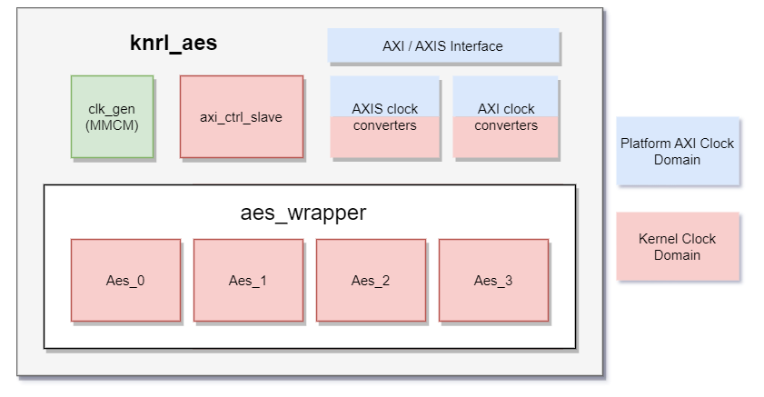
- 3 kernel execution models for Vitis acceleration application supported by XRT:
ap_ctrl_none, ap_ctrl_hs, ap_ctrl_chain (more about Supported Kernel Execution Models)
krnl_aes is mixing of ap_ctrl_non & ap_ctrl_hs modes; ap_ctrl_hs used for AES key expansion operation, host will start and wait for the finish of AES key expansion op.
ap_ctrl_none used for general AES encryption/decryption op, as soon as kernel receives input data from AXI stream slave port, it will start & finish encryption/decryption op automatically and send output data to AXI stream master port.
IP Generation
- Using 3 kinds of design IP and 2 kinds of verification IP
  - Clock generator MMCM
  - AXI clock converter
  - AXI stream clock converter
  - AXI Master VIP
  - AXIS Master VIP
  - AXIS Slave VIP
All generated by TCL script <gen_ip.tcl>
Pack the Design into Vivado IP and Vitis Kernel
To package the RTL design into Vitis kernel file (XO file).
- User can utilize GUI version RTL kernel Wizard tool to help to create the Vitis kernel
- User can use GUI version IP Packager (create plug-and-play IP to add to the extensible Vivado IP catalog) in Vivado to package the design into Vivado IP then generate the XO file
- Provide command line flow for Vitis kernel generation, provides same jobs as GUI version
- Create Vivado project and add design sources
Tcl command create_project, add_files and update_compiler_order, RTL source codes, generated IP file (xci file) and XDC file should be added
create_project krnl_aes ./krnl_aes
add_files -norecurse {
../rtl/aes_wrapper.sv ... ... \
../ip_generation/clk_gen/clk_gen.xci \
../ip_generation/axi_clock_converter/axi_clock_converter.xci \
../ip_generation/axis_clock_converter/axis_clock_converter.xci \
../krnl_aes.xdc \
}
update_compile_order -fileset sources_1
ipx::package_project -root_dir ./krnl_aes_ip -vendor xilinx.com -library user -taxonomy /UserIP -import_files -set_current true
- Infer clock, reset, AXI interfaces and associate them with clock
ipx::infer_bus_interface command to infer ap_clk and ap_rst_n as AXI bus signals
if ap_clk is the only clk, command can be omitted
Packaging RTL design into Vitis kernel file (XO file)
How to package Xilinx object (XO) file?

krnl_cbc
AXI master interfaces to access input/output data in on-board global memory, transmit/receive data via AXI stream master/slave ports. Connected with krnl_aes kernel via AXI stream ports in Vitis v++ linking stage.
Four internal processing pipes, matching the four AES engines in krnl_aes.
ap_ctrl_chain execution model supported by krnl_cbc, user can utilize hardware parallel acceleration capability without insight knowledge about # of internal engines.
Kernel Feature
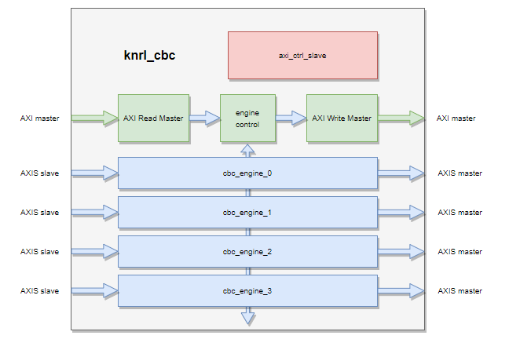
Four identical CBC engines, receiving input data from AXI read master via engine control unit. They send data to and receive output data from the krnl_aes kernel via AXI stream port, and send the result to AXI write master via the engine control unit.
AXI control slave module is used to set necessary kernel arguments. krnl_cbc kernel finishes task with input/output grouped words stored in global memory. Each internal engine will handle on words group at on time.
Consecutive input groups are assigned to different internal CBC engines in round-robin fashion by engine control module, krnl_cbc kernel uses a single kernel clock for all internal modules.
krnl_cbc kernel supports the ap_ctrl_chain execution model, ao_ctrl_chain is extension to ap_ctrl_hs model; kernel execution is divided into input sync & output sync stage.
Control signals ap_start and ap_ready used for input, ap_continue, ap_done used for output.
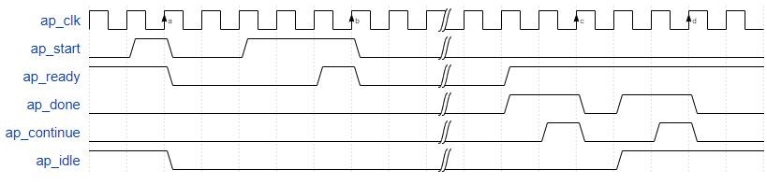
- <INPUT> Clock edge a, b: ap_start validated and de-asserted by ap_ready signal, trigger kernel execution simultaneously (similar to TVALID validated by TREADY in the AXI stream).
XRT scheduler detects status of ap_start signal, asserts ap_start when signal is low → kernel can accept a new task. ap_ready signal is generated by kernel, indicating its status.
- <OUTPUT> clock edge c, d: ap_done is confirmed and de-asserted by ap_continue signal → completion of one kernel job.
XRT scheduler detects ap_done signal has been asserted, XRT asserts ap_continue, this should be implemented as self-clear signal, keeps one cycle
- Before ap_done signal was asserted, kernel uses ap_ready signal to tell XRT that it can accept new input data. This scheme acts as back=pressure on input sync stage to enable task pipeline to fully utilize hardware capability. XRT writes ap_start bit and ap_continue bit twice each in the AXI control slave register.

Name | Addr Offset | Width (bits) | Description
CTRL | 0x000 | 5 | Control Signals.  bit 0 - ap_start  bit 1 - ap_done  bit 2 - ap_idle  bit 3 - ap_ready  bit 4 - ap_continue
MODE | 0x010 | 1 | Kernel cipher mode:  0 - decryption  1 - encryption
IV_W3 | 0x018 | 32 | AES-CBC mode initial vector, Word 3
IV_W2 | 0x020 | 32 | AES-CBC mode initial vector, Word 2
IV_W1 | 0x028 | 32 | AES-CBC mode initial vector, Word 1
IV_W0 | 0x030 | 32 | AES-CBC mode initial vector, Word 0
WORDS_NUM | 0x038 | 32 | Number of 128-bit words to process
SRC_ADDR_0 | 0x040 | 32 | Input data buffer address, LSB
SRC_ADDR_1 | 0x044 | 32 | Input data buffer address, MSB
DEST_ADDR_0 | 0x048 | 32 | Output data buffer address, LSB
DEST_ADDR_1 | 0x04C | 32 | Output data buffer address, MSB
CBC_MODE | 0x050 | 1 | Cipher processing mode:  0 - AES-ECB mode  1 - AES-CBC mode
